University of Tampa
Undergraduate Admissions
Planning Your
Recruitment Travel Season

Madison McGlone and Morgan Culp, Recruitment Ready

Planning Your Recruitment Travel Season

Analysis

Reasoning & Objectives
The University of Tampa (UT) takes pride in crafting a diverse student body. Currently, students from all 50 United States and over 130 countries attend UT. This well-represented community is thanks in large part to the Undergraduate Admissions Office’s strong recruitment efforts. Each fall and spring season, nearly two dozen admissions counselors take to the roads to recruit students from all corners of the world. Recruitment is the cornerstone for the Admissions team, and as a tuition-drive institution, this effort is critical for the University’s future success.
Recently, the Admissions team has experienced high turnover. In the past year the team has become overwhelmingly “green,” and three different individuals have managed the onboarding of these new counselors, resulting in different instruction and varying expectations.
Planning travel is a complex process that varies from counselor to counselor and season to season. This conceptual instruction aims to streamline the travel training process for this group of new counselors, while also refreshing procedures and expectations for veteran counselors. After completing this conceptual instruction counselors will map out their individual territories, be able to develop their recruitment strategy, research and create recruitment events, and finally, book, promote, and record their travels.

Audience Analysis

PRIMARY AUDIENCE: Current and New University of Tampa Undergraduate Admissions Counselors


Description

- Age: 20-65
- Gender: all genders
- Job role: Admissions counselors who are assigned a territory within or outside of the United States to recruit students from.
- Technical skills: High (knowledge of Slate, experience with booking flights, hotels, rental cars, and strong communication skills)
- Learner preferences: Online or hybrid because many counselors are out of the office at differing times due to travel
- Attitude towards training: Eager to learn and expand current travel training knowledge
Because our main audience is undergraduate admissions counselors at UT that have already been through the hiring process, we can assume that they meet the competencies we require for this instruction:

- Advanced knowledge in geography and ability to read maps, use navigation, and map out trips.
- In possession of a valid driver’s license to drive rental cars for territory travel.
- Excellent communication skills (verbal and written) to market UT and speak with prospective students, families, and counselors.
- Access to a personal or UT-issued credit card.
- Proficient knowledge of online admissions platforms such as Slate, Hobsons Rep Visits, Scoir, Outlook, and Workday.
- Access to Travel equipment including a laptop, Surface Pro, MiFi, cell phone, carry-on suitcase, UT tablecloth, tri-fold board, etc.

SECONDARY AUDIENCE: Non-travelling counselors at The University of Tampa and Admissions teams outside of The University of Tampa


Description

- Age: 20-65
- Gender: all genders
- Job role: Administrators at UT who need to be aware of the UT admissions process or admissions counselors from other schools looking to improve their recruitment efforts
- Technical skills: Low (general admissions knowledge and some Slate knowledge)
- Learner preferences: Online, flipped classroom, hybrid
- Attitude towards training: Eager to learn, curious to see what goes into this process.

Task Analysis
After completing this instruction all counselors should know how to plan, execute, promote, and record their recruitment. This encompasses a variety of steps that the instruction will detail, listed below.
LESSON # | LESSON TITLE | LEARNING OBJECTIVES
#1 | Understanding Your Territory | Counselors should be familiar with the unique culture and trends within their territory. Counselors should be able to summarize how their territory has fared in past recruitment, and how it is projected to do in the future.
#2 | Finding Recruitment Events | Counselors should be able to identify different types of recruitment events (i.e. college fairs & high school visits) and list at least three ways as to how they can seek out these events (i.e. RepVisits, Scoir)
#3 | Scheduling Events | Counselors should be able to demonstrate how to RSVP to events and which parties and platforms must be notified (i.e. Dai, Slate)
#4 | Approving Travel | Counselors should be able to describe how to compile their travel plans and present them to Stacey Fonseca for approval.
#5 | Booking Travel Logistics | Counselors should be able to demonstrate how to book all travel logistics (i.e. transportation and lodging) and be aware of budget and time considerations.
#6 | Promoting Events | Counselors should be able to demonstrate submitting a CFCR and printing confirmation letters to schools in order to promote their events.
#7 | Attending Events | Counselors should be able to summarize best practices for attending high school visits, college fairs, meetings with counselors, etc. This includes setting up tables at fairs, requesting inquiry cards, and proper dress attire and etiquette.
#8 | Expense Reimbursement | Counselors should be able to list all steps in reimbursing all their expenses within Workday immediately after a trip concludes.
#9 | Recording Travel | Counselors should be able to demonstrate how to send their inquiry cards to the administrative team for upload to Slate.

Context Analysis
Our instruction will be delivered online through an interactive medium that is easily accessible to all counselors, remote or in-person. UT’s Admissions conducts year-round travel, and has several remote employees, so having a virtual instruction module is key, as it is difficult to find time to train our staff in person face-to-face where everyone is present. Articulate will deliver this virtual instruction. This instruction will be self-regulated and self-paced.
In order to set the groundwork for this complex instruction, each counselor will bring prior knowledge regarding their assigned territory before beginning this instruction. This will allow counselors to get the most out of this training. If a counselor did not learn from the previous counselor that held their territory, they can always find past ledgers of travel seasons in the platform Slate, where all records are kept. Counselors are expected to do this to fill their knowledge gaps before beginning instruction.
Additionally, this instruction will model a “choose your own adventure” strategy given the differences within each territory. Whether a counselor is traveling locally here in Florida, elsewhere in the U.S., or out of the country entirely, they will be well-prepared to execute their travel by meeting their territory’s specific needs.
The curriculum will be broken into nine different sections that can be revisited if a counselor needs to reference something, or if a veteran counselor needs a quick refresher on a particular aspect. These steps will be laid out chronologically in the manner they should be completed to have a successful recruitment season.
- Understanding Your Territory
- Finding Recruitment Events Within Your Territory
- Scheduling Events
- Gaining Travel Approval
- Booking Travel Logistics
- Promoting Events
- Attending Events
- Expensing All Travel Fees For Reimbursement
- Recording Travel And Planning Ahead
Timing for this instruction is a major consideration, as Admissions is a cyclical and busy field. The ideal time for this instruction would be during any new counselor's onboarding process, and during each summer before all counselors embark on their fall travel season, the busiest of the two. This instruction will remain available year-round to all counselors on the Admissions team’s server, “Camilla.”

Instructional Design Plan
We based our Instructional Design Plan off of Keller’s ARCS Model of Motivation and Gagne’s Nine Events of Instruction.
ARCS Model of Motivation
Attention
- Attention will be gained by an opening presentation with all of the perks of the job: endless travel points for flights, hotels, rental cars that you get to keep for personal use. Admissions Counselor testimony on how they paid for a vacation using points.
Relevance
- This training is relevant to our learners because it is a crucial aspect of their job responsibilities. All counselors are required to travel or at least be trained on travel to execute their roles.
Confidence
- Train each UT admissions counselor in full with our travel training to obtain personal confidence within each employee to confidently go out on the road, recruit students, and be real-time problem solvers if anything were to arise.
Satisfaction
- This training will provide positive reinforcement for a job well done by awarding travel points for personal use whenever an employee joins a rewards program for hotel, flight, and rental car loyalty. These points can then be used for recreation and personal travel.
Gange’s Nine Events of Instruction
- Gain Attention
  - Attention will be gained by an opening presentation with all of the perks of the job: endless travel points for flights, hotels, rental cars that you get to keep for personal use. Admissions Counselor testimony video on how they paid for a vacation using points.
- Inform Learners of Objectives
  - After completing this conceptual instruction counselors will understand their individual territories, be able to develop their recruitment strategy, research and create recruitment events, and finally, book, promote, and record their travels.
- Stimulate Recall of Prior Knowledge
  - Think back to your knowledge on your assigned territory, places you have traveled in the past, and past interactions with students and families.
- Present the Content
  - Our content will be presented in nine sections as follows:
    - Understanding Your Territory
    - Finding Recruitment Events Within Your Territory
    - Scheduling Events
    - Gaining Travel Approval
    - Booking Travel Logistics
    - Promoting Events
    - Attending Events
    - Expensing All Travel Fees For Reimbursement
    - Recording Travel And Planning Ahead
- Provide Learning Guidance
  - Instruction will be laid out in a step-by-step format with room for counselors to select specifics related to their territory/events specific to them.
- Elicit Performance
  - Brief questionnaire checkpoints at the conclusion of each section.
- Provide Feedback
  - We will host an in-person travel meeting to discuss how effective the instruction provided was, and how it can be improved upon.
- Assess Performance
  - Get on the Road! The best way to assess performance in this field is by replicating the instruction out on your own and problem solving as you go. You will go out and complete your territory travel based off of all of the information you have been provided with and communications you have had.
- Enhance Retention and Transfer to the Job
  - Change instruction based upon feedback to make more effective for future UT Admission Counselors.

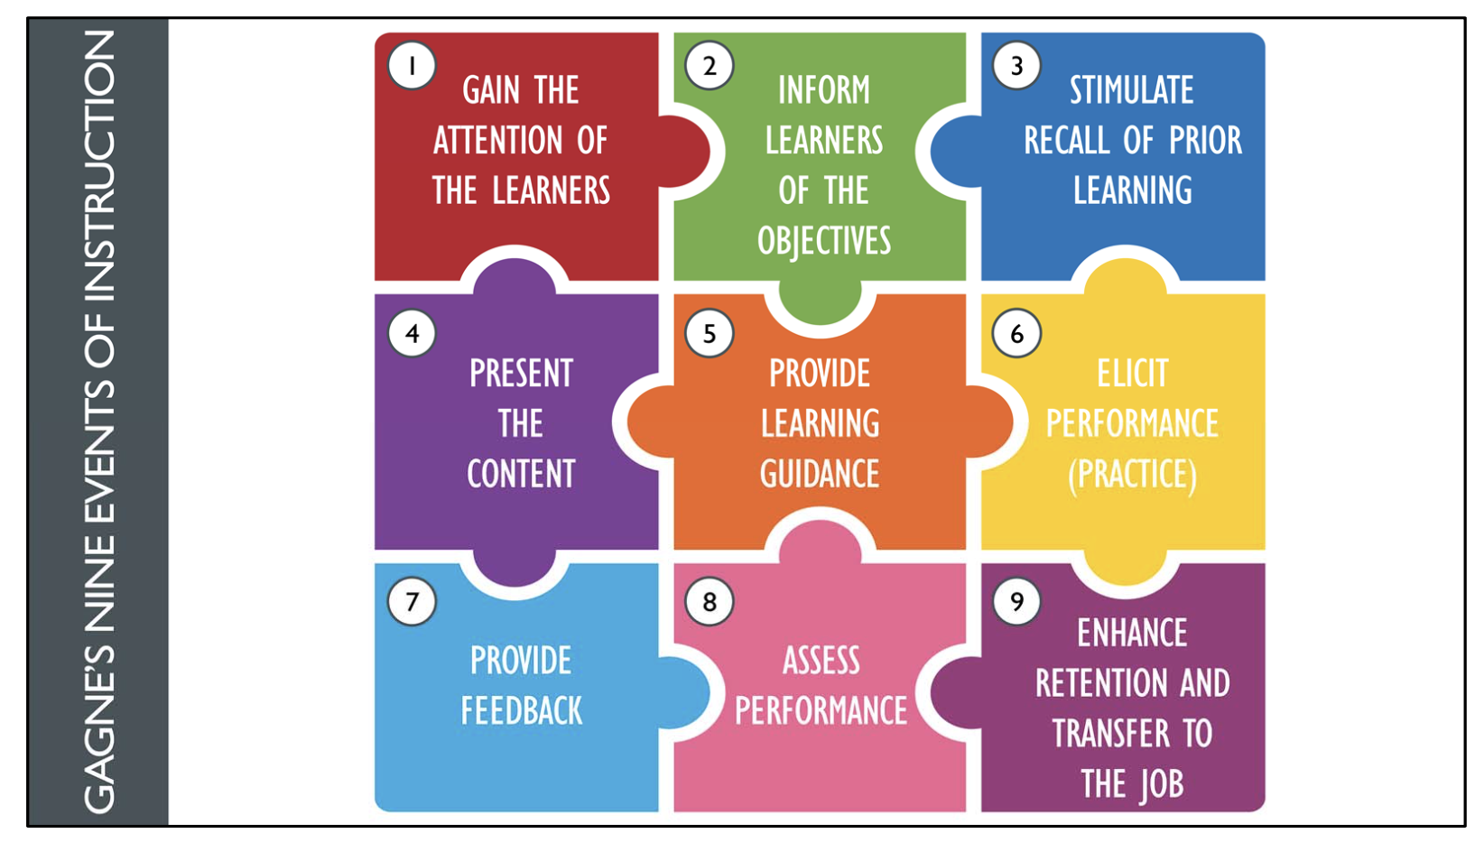
Graphic By Educational Technology

General Development Considerations
METHOD | Yes/No | DESCRIPTION
eLearning Development Tool(s) | Yes X No ☐ | This instruction will be on a virtual platform, Articulate.
PowerPoint | Yes ☐ No X | This instruction will be on a virtual platform, Articulate
Audio | Yes X No ☐ | Instruction may include video and audio components showing objectives such as setting up a college fair table.
Videos | Yes X No ☐ | Instruction may include video and audio components showing objectives such as setting up a college fair table.
Quizzes | Yes X No ☐ | Short quizzes may be listed at the end of a section for check point of learning
Photography | Yes X No ☐ | Photos of table setups, etc. will be included.
Graphics | Yes X No ☐ | Graphics will be included to show setups and decision making tools.
Social Media | Yes ☐ No X | Social media will not be used.
Handouts | Yes ☐ No X | Instruction is all online.
Pre-Work Assignments | Yes X No ☐ | Overview Admissions Counselor new-hire training
Translation | Yes ☐ No X | All instructions will be delivered in English.

Instructional Prerequisites
Because our main audience is undergraduate admissions counselors at UT that have already been through the hiring process, we can assume that they meet the competencies we require for this instruction:
- Advanced knowledge in geography and ability to read maps, use navigation, and map out trips.
- In possession of a valid driver’s license to drive rental cars for territory travel.
- Excellent communication skills (verbal and written) to market UT and speak with prospective students, families, and counselors.
- Access to a personal or UT-issued credit card.
- Proficient knowledge of online admissions platforms such as Slate, Hobsons Rep Visits, Scoir, Outlook, and Workday.
- Access to Travel equipment including a laptop, Surface Pro, MiFi, cell phone, carry-on suitcase, UT tablecloth, tri-fold board, etc.
In addition, all counselors must complete the general new hire training before moving on to the travel training, and be familiar with their territory.

Pre-Instruction
PRE-TRAINING ACTIVITIES
Description of Activity | Objectives | Audience
General New Hire Training | Onboard all new hires and teach them the ins and outs of all job responsibilities | All new counselors
Territory Knowledge | Counselors must demonstrate their territory knowledge before accessing the travel training. They should be able to list feeder schools, describe their territory’s unique culture, and summarize recruitment efforts in their territory in the past. | All counselors

Post Instruction
Describe any post-training activities that will occur before and after the training. This might include post- assessments, post-readings, surveys, etc.
POST-INSTRUCTION ACTIVITIES
Description of Activity | Objectives | Audience
Post-Instruction Quiz | This quiz will measure mastery of the subject. It will contain short-answer, multiple choice, and list questions to determine if counselors have understood the material and prepared to develop and execute their own recruitment season. (i.e. List 3 different ways to schedule visits) | All counselors who have completed travel training.
Face-to-Face Discussion | This discussion will serve as a reflection and resource chat. Counselors will reflect on the new training, sharing their thoughts and what they would like to see changed or strengthened. Counselors will also be able to crowdsource travel tips and tricks based on their past experience. | All counselors who have completed travel training and work on-site.

Rapid Prototype
Below are a few mock ups that demonstrate the overall look and feel, and approach of the course.
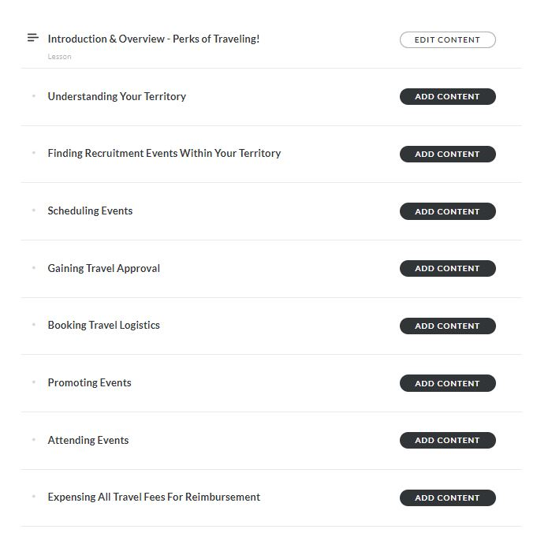
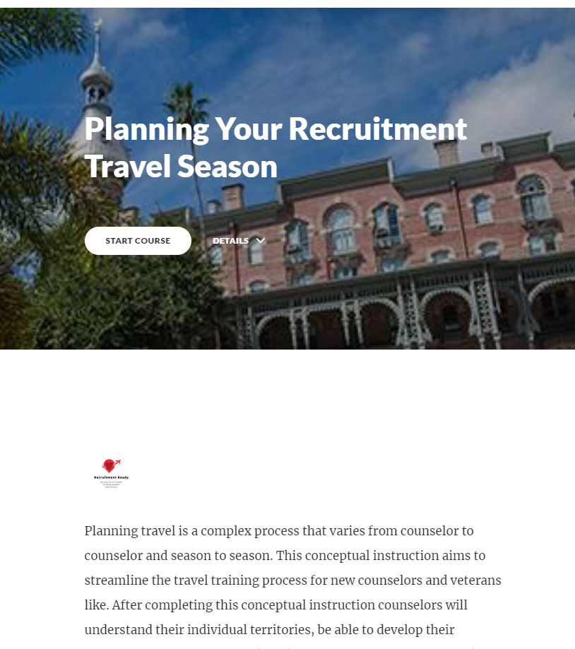

Existing Content
Currently, the Admissions team has a general training manual that serves to train all new hired counselors. We will reference this document to match the style and tone, and incorporate some aspects including the Admissions timeline that references when during the cycle it is best to approach travel planning portions. This manual is housed in the admissions team server, Camilla.

